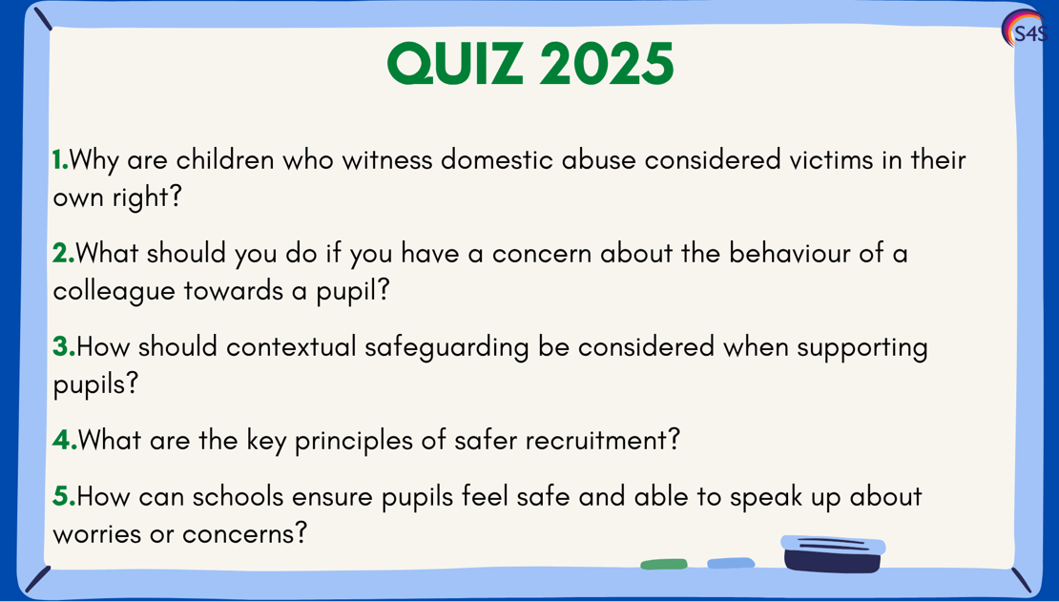

1. **Answer:** Because witnessing domestic abuse can have a significant and lasting impact on a child’s emotional and psychological wellbeing, even if they are not directly harmed.
2. **Answer:** You must report it immediately to the headteacher or the designated safeguarding lead (DSL). If the concern is about the headteacher, it should be reported to the chair of governors or the Local Authority Designated Officer (LADO), following the school’s whistleblowing or allegations procedure.
3. **Answer:** Staff should consider risks that occur outside the home, such as peer influence, exploitation, or online abuse, and ensure support and intervention reflects the wider context of a child's life.
4. **Answer:** Conducting thorough pre-employment checks, ensuring clear job descriptions and person specifications, using structured interviews, and maintaining vigilance throughout employment to uphold safeguarding standards.
5. **Answer:** By fostering a trusting, inclusive environment where relationships are positive, pupils know who to talk to, safeguarding is discussed openly (e.g. through PSHE), and staff consistently show they are approachable and responsive.