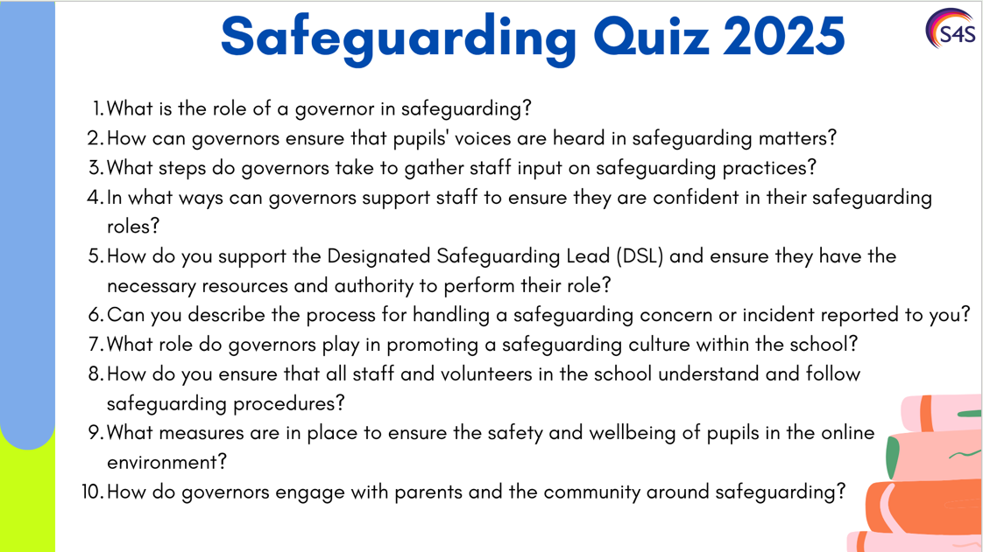

- Answer: Governors have strategic oversight of safeguarding. They ensure that safeguarding policies are in place, statutory guidance is followed, and that the school fosters a culture where safeguarding is a priority. They do not manage individual cases but monitor effectiveness and compliance.
- Answer: By reviewing feedback from pupil voice activities (e.g. surveys, school council input), meeting with pupils during visits, and ensuring safeguarding policies and curriculum promote open communication.
- Answer: By meeting with staff during monitoring visits, reviewing safeguarding audit outcomes, and ensuring staff are surveyed or consulted about training needs and confidence levels.
- Answer: By ensuring that safeguarding training is up to date and relevant, monitoring staff confidence through feedback, and encouraging a culture where staff feel supported in reporting concerns.
- Answer: By meeting regularly with the DSL (or safeguarding governor doing so), reviewing their workload, ensuring they have time and resources to carry out their role, and advocating for safeguarding to be prioritised at leadership level.
- Answer: Concerns should be directed to the DSL. If the concern relates to a staff member, the headteacher should be informed. If it concerns the headteacher, it must be referred to the chair of governors or LADO. Governors must not investigate but follow the school’s safeguarding and whistleblowing policies.
- Answer: By modelling safe, transparent behaviour, maintaining regular oversight of safeguarding, ensuring policies are reviewed and lived, and holding leaders to account for creating a safe environment for pupils and staff.
- Answer: By monitoring induction processes, reviewing training records, sampling safeguarding audits, and ensuring the safeguarding policy is known, accessible, and regularly reviewed.
- Answer: Governors should check that online safety is included in the curriculum, filtering and monitoring systems are effective, and pupils, staff, and parents receive guidance on digital risks and safe behaviour online.
- Answer: Through communication channels like newsletters or meetings, ensuring the website includes key safeguarding information, and ensuring that safeguarding concerns raised by parents are responded to appropriately.

